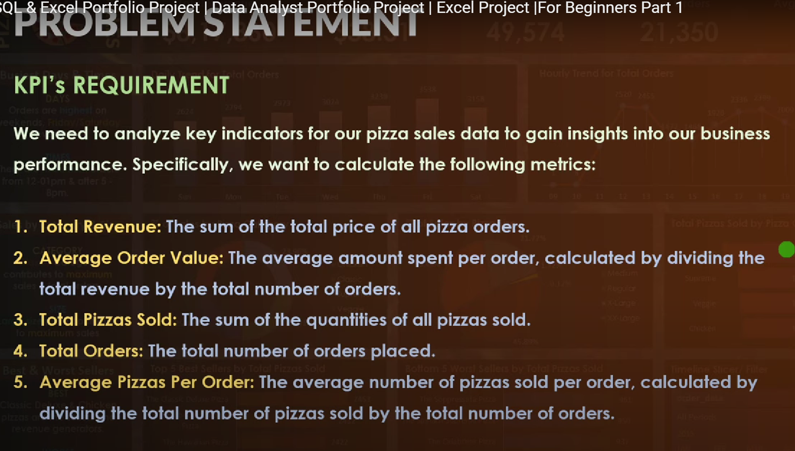

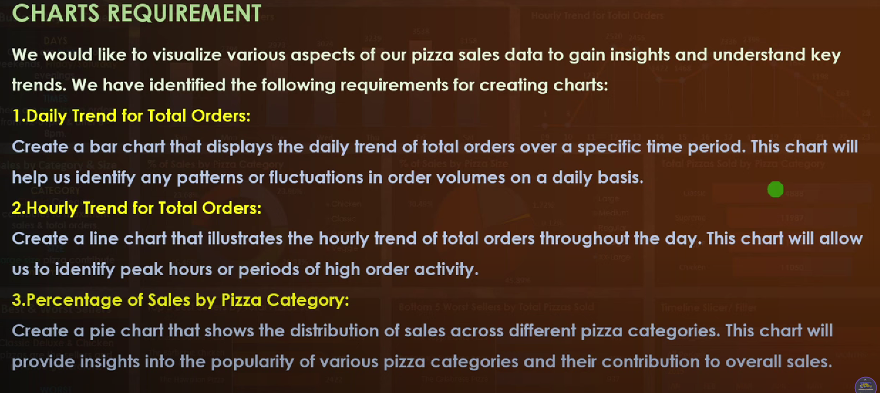

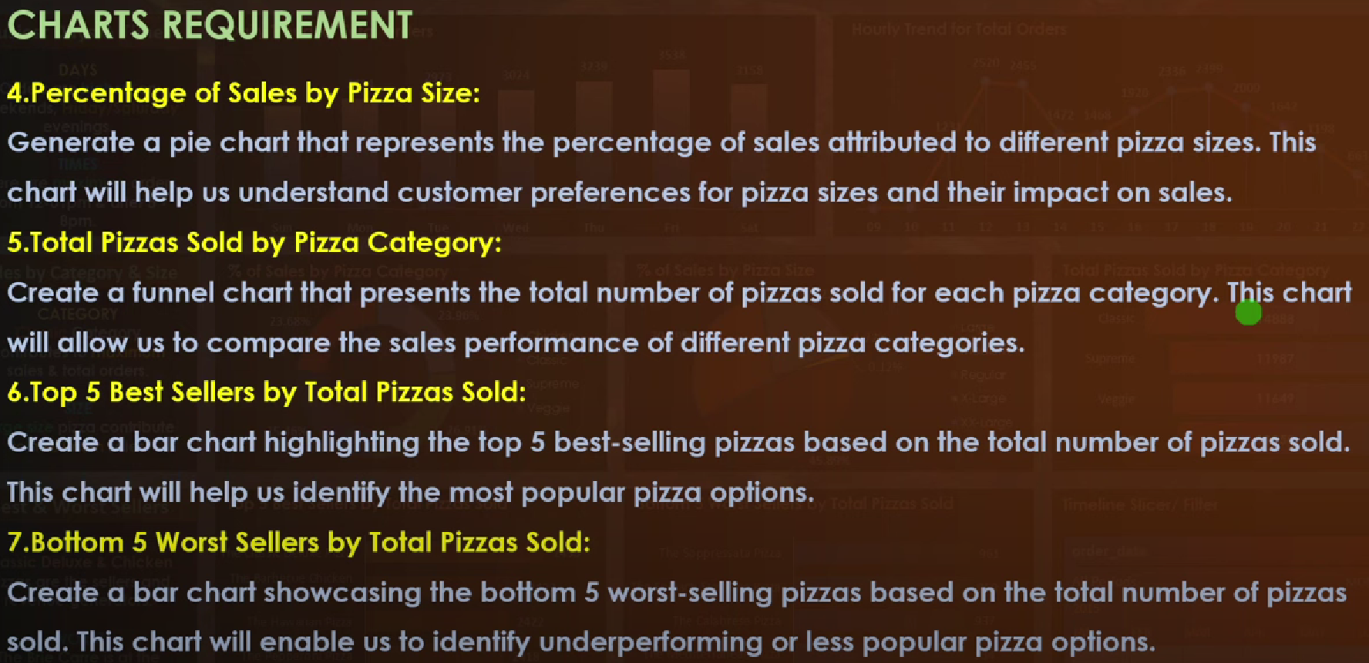

KPI’S REQUIREMENT

1. TOTAL REVENUE





1. AVERAGE ORDER VALUE





1. TOTAL PIZZAS SOLD





1. TOTAL ORDERS





1. AVERAGE PIZZAS PER ORDER





To get answer in decimal we use “CAST FUNCTION”





What is DECIMAL(10, 2): It means that it will only display digits of about 2 decimal places out of 10 decimal places.

CHARTS REQUIREMENT

1. DAILY TREND FOR TOTAL ORDERS

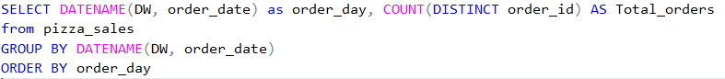

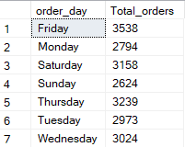

Whenever we use Function Datename and another column count we must use Group by

1. HOURLY TREND FOR TOTAL ORDERS

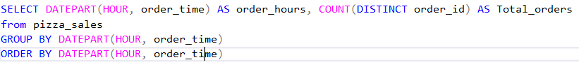

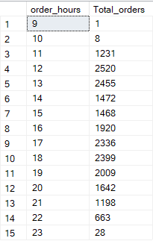

1. PERCENTAGE OF SALES BY PIZZA CATEGORY



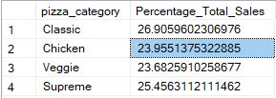

FOR THE MONTH OF JANUARY

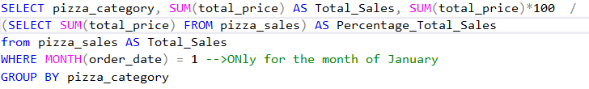

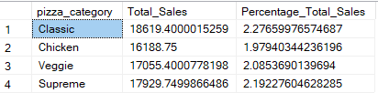

1. PERCENTAGE OF SALE BY PIZZA SIZE

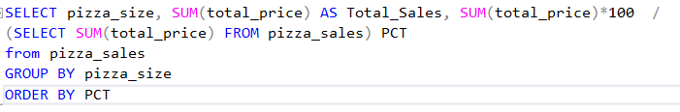

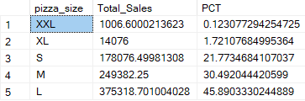

MUCH MORE ELABORATIVE CODE

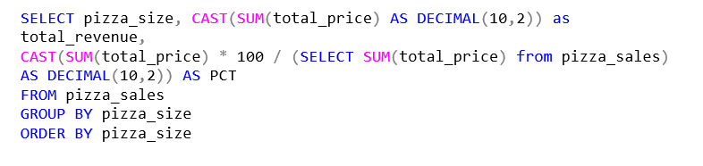

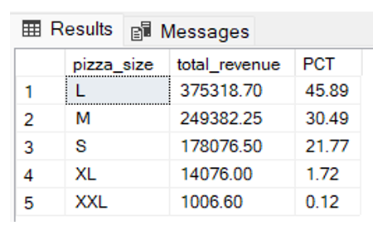

1. TOTAL PIZZAS SOLD BY PIZZA CATEGORY

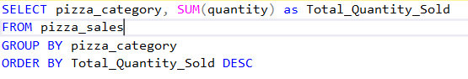

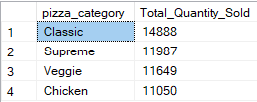

FOR THE MONTH OF FEBRUARY

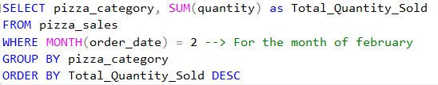

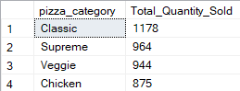

1. TOP 5 BEST SELLERS BY TOTAL PIZZAS SOLD

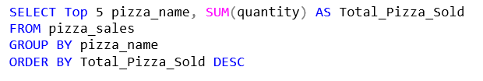

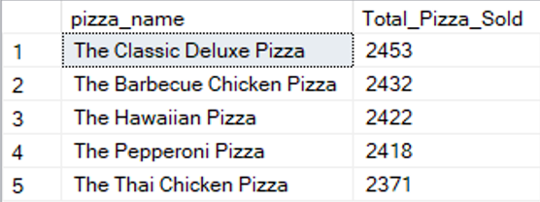

1. BOTTOM 5 BEST SELLERS BY TOTAL PIZZAS SOLD

